# Web Technologies project support worksheet 2

1. Make sure you’ve created the database and table structure

You should by now have created the database and database structure for your project. If not, please return to **Project support worksheet 1** and complete.

1. Creating data structure in Excel

Open an Excel spreadsheet and save it as **project_schema.xlsx**. For each of the above tables, create a worksheet with the name of the table.

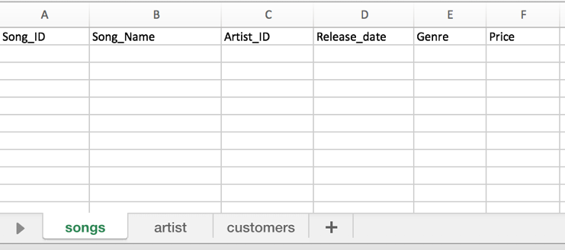

1. Populating data in Excel.

Now you have created your data structure, make a start on populating the three tables with realistic data for your project. You do not have to complete the data right now, but have a good go at creating a reasonable body of data. Use iTunes or another music sites for ideas of songs / artists.

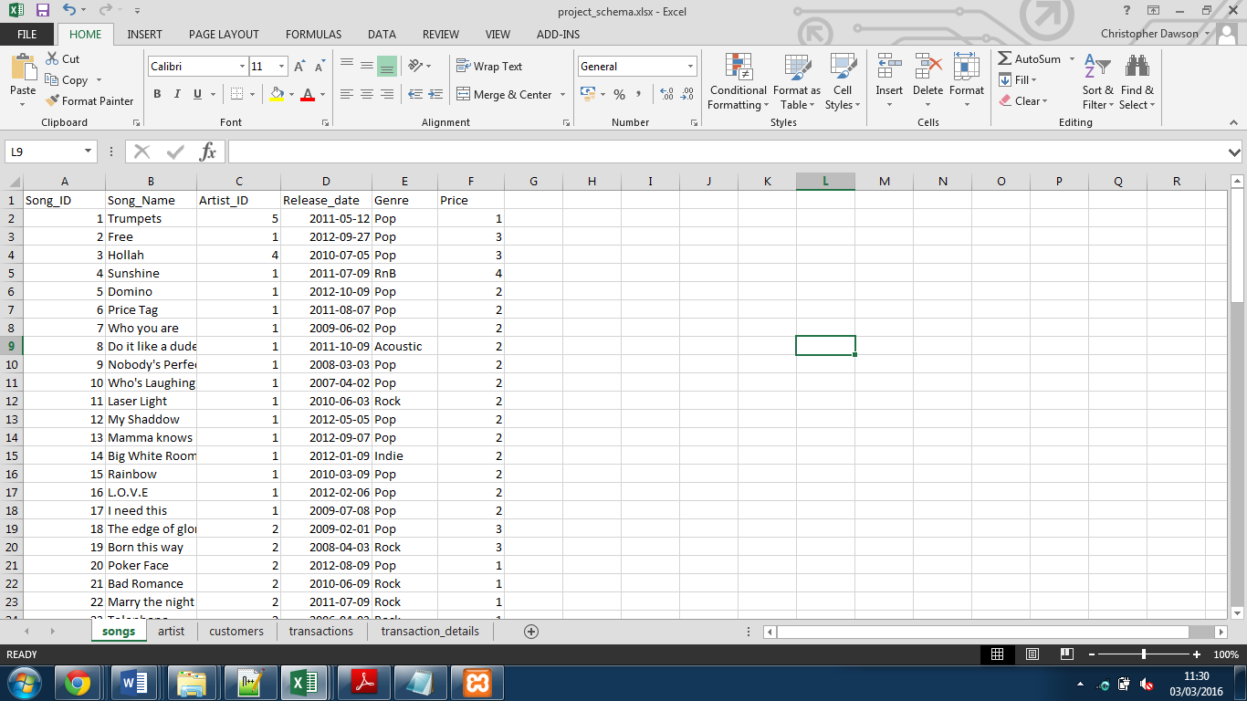

**NB – Dates should be entered in the YYYY-MM-DD format shown above.**

Pay particular attention to ID numbers that you use in the song table table as foreign key. Above we have not included the artist name in the song table, but the artist ID. This way for a given song we can link to all the information about a given artist (stored in the artists table).

When assigning the artist ID as foreign keys you need to make sure that the ID in question exists in the reference table, otherwise this will cause problems with your queries.

Furthermore, without properly referenced foreign keys, when you set up a foreign key constraint, the data will be rejected.

1. Adding some more test data to the songs table

Now, using the GUI, add about 4 to 5 lines of data to your **songs**, **artists** and **customers** table.

1. Carrying out test queries

Now try writing out the following queries for your project using the structures provided:

In order to write out the query for view customers (**3.4** of ACW2 brief), you need to view **first name**, **last name** and **email** of all customers in the table:

SELECT field1, field2, etc FROM table ORDER BY field2 ASC;

In order to write out the query for inserting customers (**3.3** of ACW2 brief), you need to enter **first name**, **last name** and **email** into the **customers** table:

INSERT INTO table(field1, field2, etc) VALUES('value1', 'value2' etc);